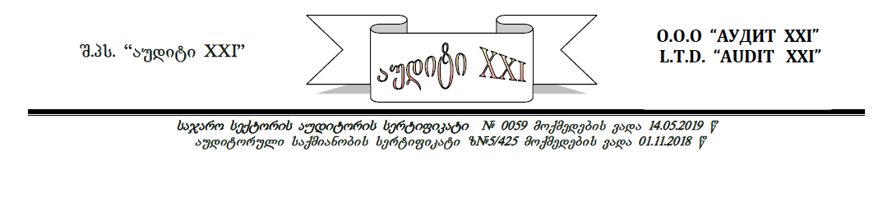

# Satitulo gverdi

***Sefasebis daskvna***

***ssip adigenis municipalitetis sofel kaxareTis sajaro skolis ბalansze ricxuli skolis Senobis Rirebulebis, demontaJisa da demontaJis Sedegad misaRebi meoradi samSeneblo masalebis sabazro Rirebulebis gansazRvris Sesaxeb***

***damkveTi:*** *ssip adigenis municipalitetis sofel kaxareTis sajaro skola* *(s/k 222728029)*

***Semsrulebeli:*** *Sps “auditi XXI” (s/k: 204420803)*

***Sefasebis TariRi: 31 agvisto 2023 w.***

***danarTi:*** *() furceli*

**

# werili

ssip adgenis municipalitetis

sofelkaxareTis sajaro skolis

direqtors qalbaton qeTevan afriamaSvils

qalbatono qeTevan,

ssip adigenis municipalitetis sofel kaxareTis sajaro skolasa da Sps “auditi XXI_s” Soris 2023 wlis 25 agvistos gaformebuli saSemfaseblo-saeqsperto momsaxurebis Sesaxeb xelSekrulebis Tanaxmad Semfasebelma eTerი gogiam ganvaxorciele ssip adigenis municipalitetis sofel kaxareTis sajaro skolis balansze ricxuli skolis Senobis sabalanso Rirebulebis, misi demontaJisa da demontaJis Sedegad misaRebi meoradi samSeneblo masalebis Rirebulebis gansazRvris samuSaoebi.

Sefasebis obieqtis fizikuri da samarTleblivi monacemebi moyvanilia am daskvnis Sesabamis nawilebSi. Sefaseba ganxorcielebulia 2023 wlis 31 agvistos mdgomareobiT.

daskvnaSi moyvanili faqtebisa da garemoebebis gaTvaliswinebiT, ssip adigenis municipalitetis sofel kaxareTis sajaro skolis balansze ricxuli skolis Senobis Rirebuleba, demontaJisa da demontaJis Sedegad misaRebi meoradi samSeneblo masalebis sabazro Rirebuleba ganisazRvra:

* **arsebuli skolis Senobისa da minaSenis narCeni sabalanso Rirebuleba Seadgens–140 600 (asormoci aTas eqvsasi) lars.**

**amave skolis Senobis demontaJi da narCenebis gatanis Rirebuleba– 6 800 (eqvsi aTas rvaasi)lars;**

**demontaJis Sedegad misaRebi meoradi samSeneblo masalebis sabazro Rirebuleba –21 875 (ocdaerTi aTas rvaas samocdaTxuTmeti) lars**

warmodgenili Sefaseba Sesrulebulia saqmis codniTa da udidesi pasuxismgeblobiT, qonebis Sefasebis saerTaSoriso komitetis “Sefasebis saerTaSoriso standartebis” Sesabamisad saqarTveloSi moqmedi Sesabamisi normatiuli aqtebis sruli dacviT.

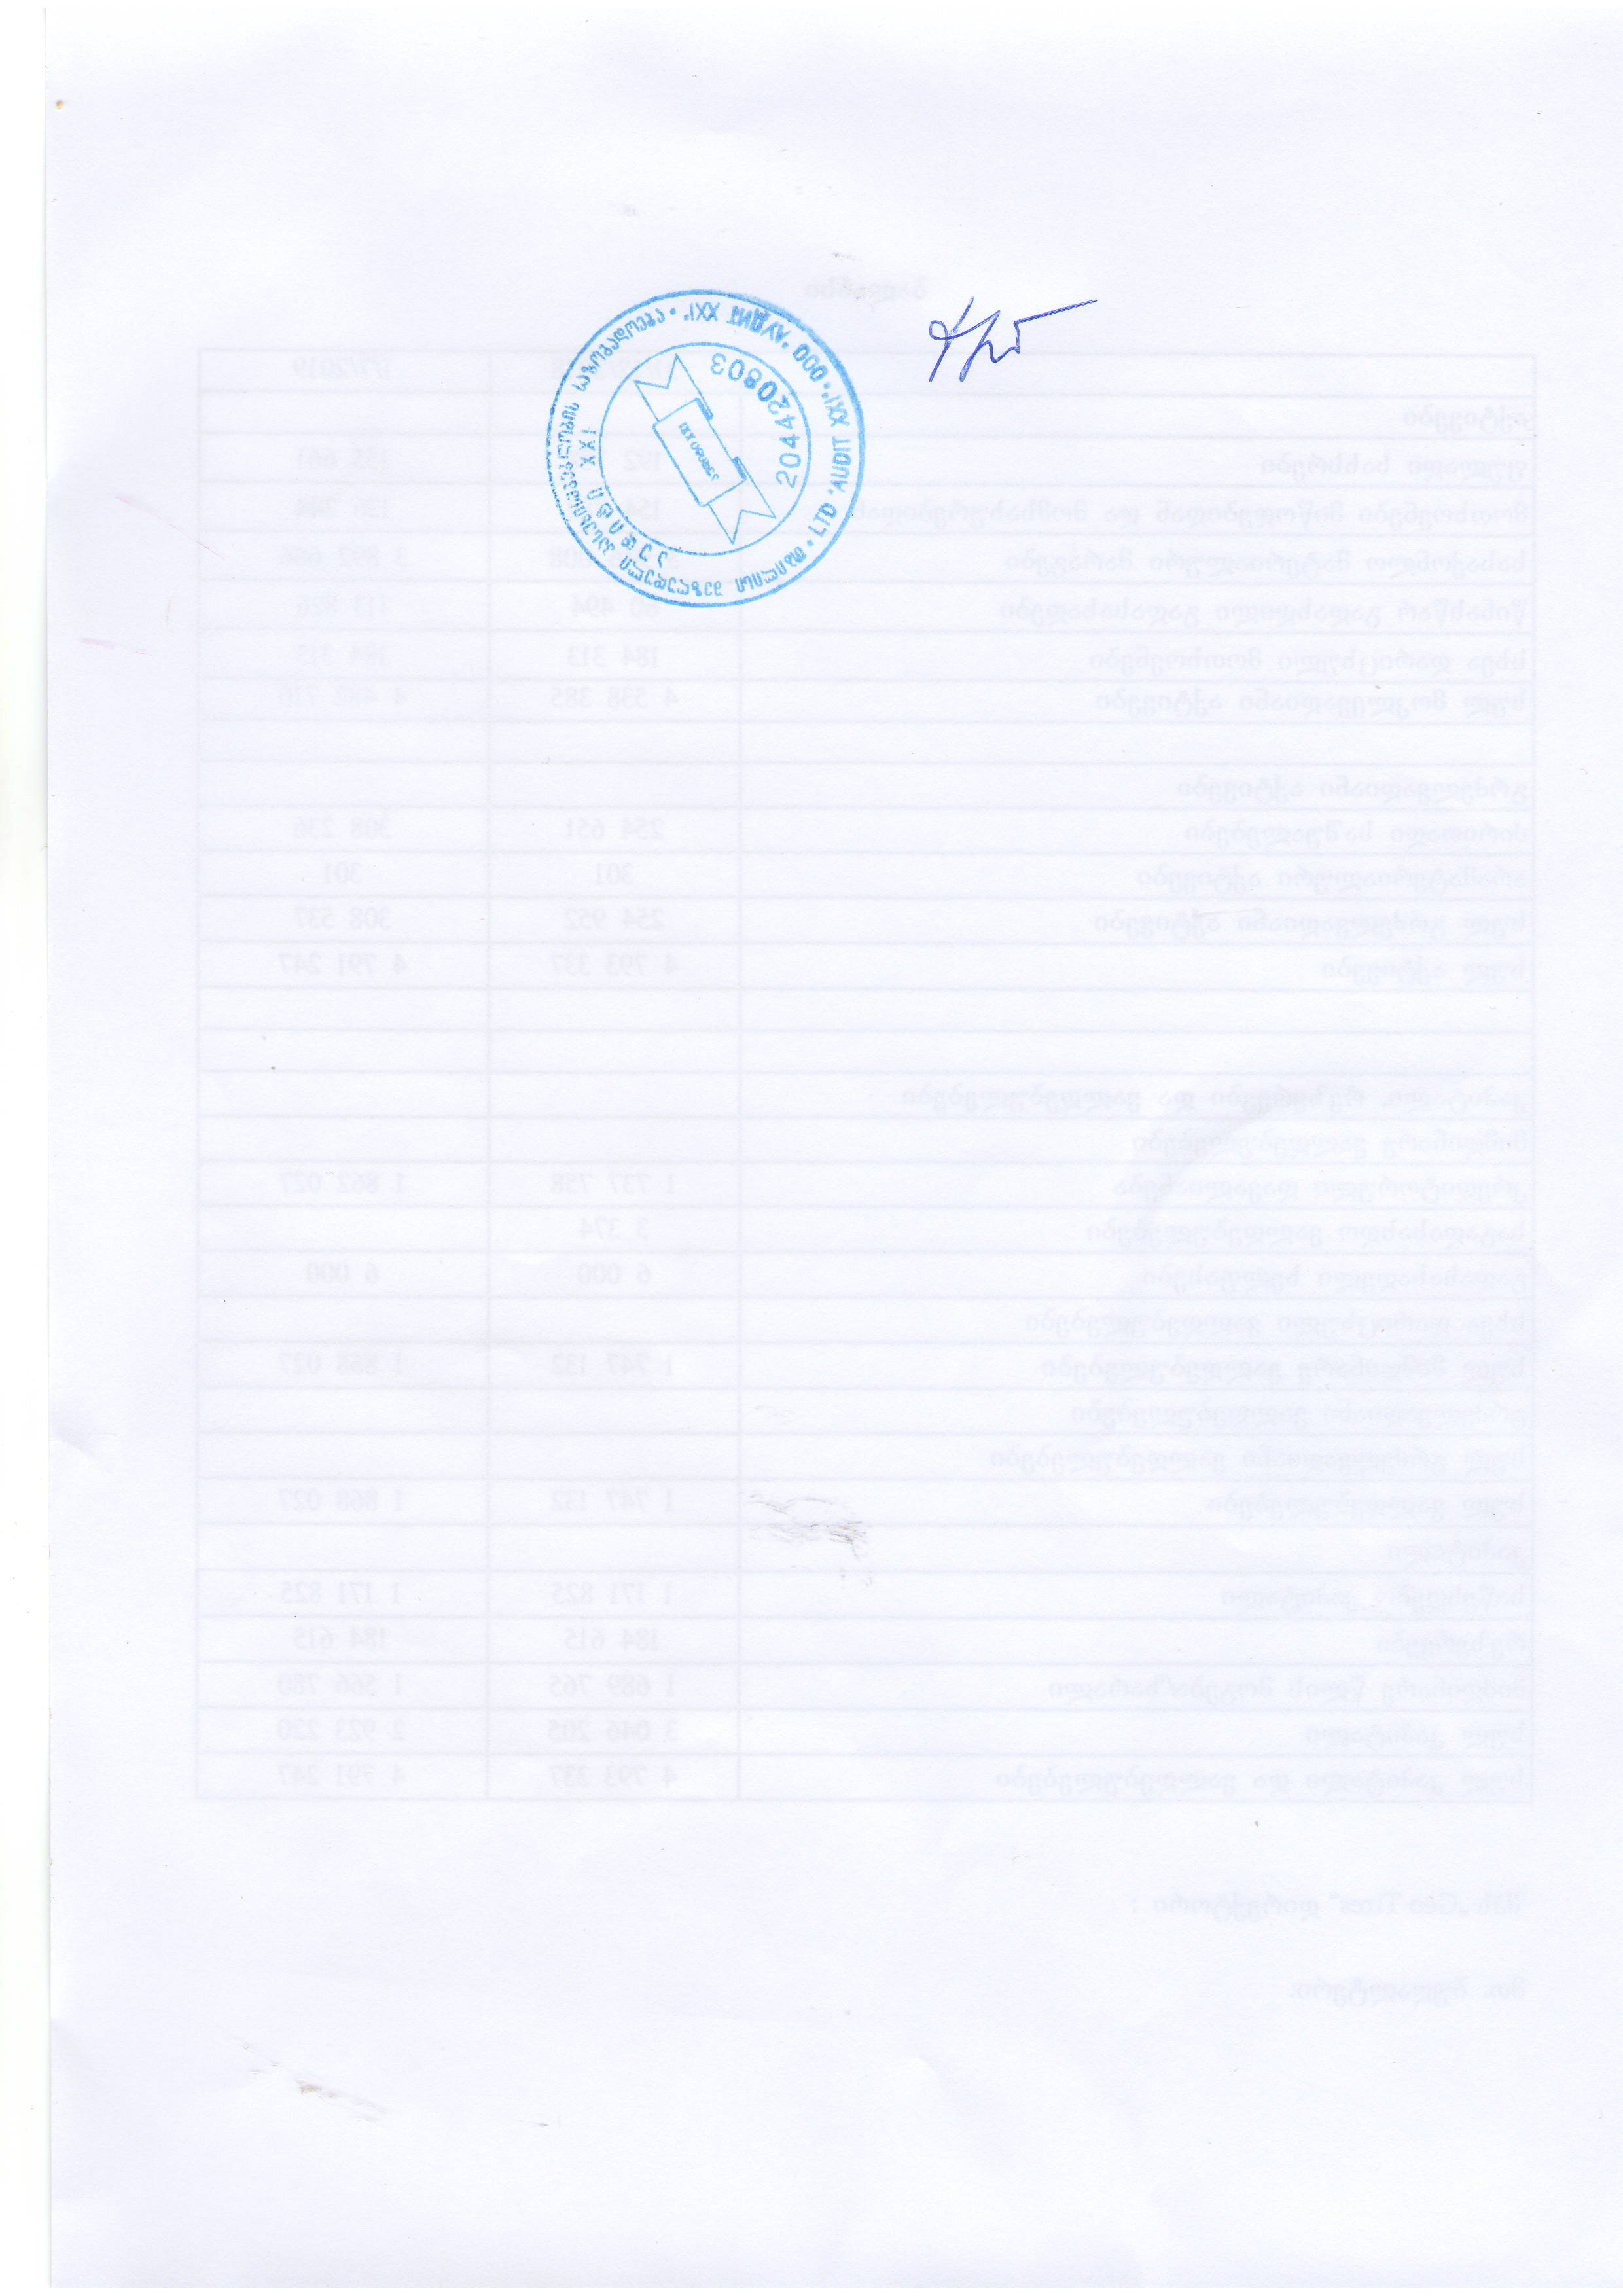

**pativiscemiT**

**Sps „auditi XXI_is” direqtori: eTeri gogia**

31 agvisto 2023 weli

# 

# Sinaarsi

satitulo gverdi 1

werili 2

Sinaarsi 4

qonebis Sefasebis angariSi 5

Sefasebis serTifikatebi 5

SemzRudavi pirobebi da daSvebebi 6

1.zogadi saSemfaseblo nawili 7

1.1 mniSvnelovani faqtebis mokle mimoxilva 7

Sefasebis procesi da meTologia 8

inspeqtirebis Sedegebi 11

skolis balansze ricxuli Senobis sabalanso Rirebulebis, demontaJis Rirebulebis da demontaJis Sedegad misaRebi masalebis Rirebulebis gansazRvra 11

daskvna 14

danarTi --------------------------------------------------------------------------------------15

# 

# qonebis Sefasebis angariSi

## **Sefasebis serTifikatebi**

Sefaseba Sesrulebulia auditor/Semfasebeli eTeri gogias mier (p/n 01013003569), buRaltruli aRricxvis, angariSgebisa da auditis zedamxedvelobis samsaxuris mier miniWebuli auditoris individualuri saregistracio nomeri - SARAS-A-674437, [https://www.saras.gov.ge/](https://www.saras.gov.ge/ka/Register/RegisterAuditorCompanies)), romelic aris saqarTvelos auditorTa, buRalterTa da finansur menejerTa profesiuli federaciis wevri, registraciis # ფპ/ა-044, aseve flobs auditoruli saqmanobis sertifikats z#5/425, moqmedebis vada-uvado, sajaro seqtoris auditoris # 0331 sertifikats, SemfasebelTa da eqspertTa profesiuli ganviTarebis centris sertifikaciis organos mier gacemul uZravi qonebis Semfaseblis Sesabamisobis serTifikats (A-0947), SemfasebelTa da eqspertTa profesiuli ganviTarebis centris sertifikaciis organos mier gacemul moZravi qonebis Semfaseblis Sesabamisobis serTifikats (P-0790), aris buRalterTa da finansur menejerTa federaciis wevri, saqarTvelos damoukidebel SemfasebelTa wevri

vadastureb, rom:

* angariSSi asaxuli analizi emyareba garkveul daSvebebs, SemzRudav pirobebs da aris Cemi, Semfaseblebis piradi, miukerZoebeli profesionaluri mosazrebebi da mis safuZvelze gakeTebuli daskvnebi;
* uZravi da moZravi qonebis Sefasebis angriSSi asaxuli yvela monacemi warmodgenilia sworad da Seesabameba realobas;
* Semfasebels arc amJamad da arc momavalSi ar gaaCnia aranairi interesi im uZravi da moZravi qonebis mimarT, romlis Sefasebac warmodgenilia angariSSi;
* Semfasebels gaaCnia sakmarisi codna, kvalifikacia da gamocdileba Sesafasebeli qonebis sworad SefasebisaTvis;
* Sefasebis procesi - informaciis mopoveba, analizi da vizualuri daTvaliereba ganxorcielda saerTaSoriso standartebis Sesabamisad.

**Semfasebeli: eTerი gogia**

31 agvisto 2023 weli

## **SemzRudavi pirobebi da daSvebebi**

warmodgenili SezRudvebi da daSvebebi Seadgenen mocemuli kvlevis ganuyofel nawilს

1. warmodgenili angariSi, masSi miTiTebuli miznebisa da amocanebisaTvis, misaRebia mxolod mTliani moculobiT;
2. Semfasebeli ar iRebs pasuxismgeblobas Sesafasebeli qonebis sakuTrebis uflebis iuridiul mxareze, romelzec xelmisawvdomoba miRebulia werilobiT an zepiri formiT SemkveTisagan. Sesafasebeli qonebis sakuTrebis ufleba ganxilulia, rogorc Tavisufali nebismieri pretenziisagan;
3. Sesafasebeli qoneba vizualurad daTvalierebul iqna Cems mier, am mizniT saTanadod Seswavlil iqna saqarTvelos bazris koniunqtura;
4. mtkicebulebebi, romelic Semfasebelma miiRo mesame mxarisagan da igi asaxulia angariSSi iTvleba utyuarad. Tumca Semfasebeli ver uzrunvelyofs informaciis absoluturi sizustis garantias, amitom im SemTxvevaSi, rodesac es aucilebeli, vuTiTebT informaciis wyaros;
5. Semfasebeli ar aris valdebuli raime saxiT iyos pasuxismgebeli Sefasebis Sedegebze (gamocxaddes sasamarTloSi, iyos mowme warmodgenili angariSTan an Sefasebul qonebasTan dakavSirebiT da a.S.), im SemTxvevis garda, roca es xdeba kerZo xelSekrulebiT an da sasamarTlos oficialuri gamoZaxebiT.
6. Sefasebis obieqtis Sesaxeb Semfaseblis mosazreba namdvilia Sefasebis TariRisaTvis. Semfasebeli ver aiRebs pasuxismgeblobas im socialuri, ekonomikuri, iuridiuli da bunebrivi pirobebis cvlilebebis Sedegebze, romelmac SeiZleba gavlena moaxdinos Sesfasebeli obieqtis mdgomareobaze.

# 1.zogadi saSemfaseblo nawili

## **mniSvnelovani faqtebis mokle mimoxilva**

|  |  |
| --- | --- |
| **daskvnis #:** | 25/8/2023 |
| **Sefasebis safuZveli:** | klientsa da Semfasebels Soris 2023 wlis 25 agvistos gaformebuli xelSekruleba saSemfaseblo momsaxurebis Sesaxeb. |
| **damkveTi:** | ssip adigenis municipalitetis sofel kaxareTis sajaro skola. |
| **Sesafasebeli qoneba (Sefasebis obieqti):** | 61.15.24.461 sakadastro kodze arsebuli ssip adigenis municipalitetis sofel kaxareTis sajaro skolis balansze ricxuli skolis Senobis, demontaJisa da demontaJis Sedegad misaRebi meoradi samSeneblo masalebis sabazro Rirebulebis gansazRvra |
| **tipi:** | Semfaseblis azriT Sefasebis obieqti warmoadgens specializirebuli qonebis tips. |
| **misamarTi:** | adigenis municipalitetis sofeli kaxareTi (sakadastro kodi 61.15.24.461 ) |
| **mesakuTre:** | saxelmwifo |
| **Sefasebis mizani:** | LkaxareTis skolis balansze ricxuli skolis Senobis Rirebulebis, minaSenis, demontaJisa da demontaJis Sedegad miRebuli meoradi samSeneblo masalebis sabazro Rirebulebis gansazRvra |
| **Sefasebis savaraudo gamoyeneba:** | F  finansuri angariSgeba |
| **Sefasebuli ufleba:** | sakuTrebaze mTliani ufleba |
| **TariRebi:L** | qonebis Rirebulebis Sefasebis TariRia 31.08..2023 w, inspeqtirebis TariRi 25.08.2023-31.08..2023 weli, daskvnis momzadebis TariRi: 31.08 2023 weli. |

# Sefasebis procesi da meTologia

Cvens mier Sesafasebel qonebas warmoadgens ssip adigenis municipalitetis sofel kaxareTis sajaro skolis balansze ricxuli skolis Senobis Rirebulebis, demontaJisa da demontaJis Sedegad misaRebi meoradi samSeneblo masalebis sabazro Rirebulebis gansazRvra.

saqarTvelos kanonmdeblobis Sesabamisad:

“Senoba-aris iseTi nageboba, romelic qmnis gadaxurul sivrces, SemosazRvruls kedlebiT, kolonebiT an sxva SemomsazRvreli konstruqciebiT.”;

“nageboba-aris samSeneblo masalisa da nakeTobebisagan Seqmnili konstruqciuli sistema, romelic gruntTan uZravad aris dakavSirebuli.”;

praqtikaSi ZiriTadad gamoiyeneba qonebis Sefasebis sami ZiriTadi meTodi:

* qonebis Sefaseba danaxarjebis meTodiT;
* qonebis Sefaseba gayidvebis analizis meTodiT;
* qonebis Sefaseba Semosavlebis kapitalizaciis meTodiT;

samive meTodis gamoyenebis ZiriTad amocanas warmoadgens qonebis “sabazro Rirebulebis” gansazRvra. sabazro Rirebuleba warmoadgens im “fulad sidides, romliTac gaicvleba qoneba Sefasebis TariRisTvis dainteresebul myidvelsa da gamyidvels Soris “gaSlili xelis” principis dacviT, saTanado marketingis Catarebis Semdeg, rodesac TiTouli mxare moqmedebs gaTviTcnobierebulad, windaxedulad da Zaldatanebis gareSe”.

zemoT CamoTvlili meTodebidanDCvens mier Sesafasebeli qonebis specifikidan gamomdinare sabazro Rirebulebis Sefaseba Semosavlebis kapitalizaciis da gayidvaTa Sedarebis meTodebiT rTuli da araefeqturia. amitom qonebis Sefasebisas gamoviyeneT Sefaseba danaxarjebis meTodiT.

qonebis danaxarjebis meTodis Sefasebis gamoyenebiT gansazRvruli uZravi qonebis sabazro Rirebuleba gulisxmobs miwis nakveTis (rogorc Tavisufalis) da masze arsebuli gaumjobesebebis Rirebulebis jams cveTis gaTvaliswinebiT.

qonebis sabazro Rirebulebis danaxarjebis meTodiT Sefasebisas dacul iqna Semdegi Tanmimdevroba:

* skolis balansze ricxuli Senobis aRdgeniTi an Canacvlebis Rirebulebis gaangariSeba.
* Senobebis yvela saxis cveTis gaangariSeba.
* Senobebis aRdgeniT Rirebulebas minus gamoangariSebuli cveTis Tanxa.D

danaxarjebis meTodis gamoyenebisas Sesafasebeli Senobis aRdgeniTi Rirebulebis jami Seadgens im danaxarjebis jams, romelic unda gaswios tipiurma myidvelma drois konkretul momentSi mocemul miwis nakveTze imave daniSnulebis Senobis an nagebobis aSenebisaTvis, igive masalebis, igive xarisxis samuSao Zalis, igive teqnologiebis gamoyenebiT, rac gamoyenebul iqna Tavis droze Sesafasebeli obieqtis asaSeneblad.

Canacvlebis Rirebuleba aris danaxarjebis is jami, romelic saWiroa Sefasebis momentisaTvis Sesafasebeli obieqtis msgavsi Senobis aSenebisaTvis Tanamedrove masalebis, standartebisa da teqnologiebis gamoyenebiT.

aRniSnuli meTodiT Sefasebisas gaTvaliswinebul iqna:

* Sesafasebeli obieqtis asaki:

damkveTis ganmartebiT Sesafasebeli skolis teritoriaze ganlagebuli Senobis aSenebis TariRia 2007 weli

* mSeneblobis Rirebulebis struqtura:

**a). pirdapiri danaxarjebi (80%)**

* masalebis Rirebuleba;
* samSeneblo xarjebi;
* muSaxelis anazRaureba;
* mSeneblobis mogeba da zednadebi xarjebi;
* satransporto xarjebi;
* da samSeneblo saqmianobisaTvis gasawevi sxva xarjebi.

**b). iribi damaxarjebi (20%)**

* profesionaluri momsaxurebis xarjebi:

1. arqiteqtoris/dizaineris (inJineris) momsaxurebis xarjebi;

2. iuridiuli momsaxurebis xarjebi;

3. sxva xarjebi:

* + - xarjebi nebarTvebze;
    - sadazRvevo xarjebi;
    - sxva xarjebi.

danaxarjebis (Canaცvlebis) meTodi Tavis mxriv moicavs 3 meTods:

1. kvadratuli (kuburi) metrebis) meTodi;

2. elementobrivi (saxarjTaRricxvo) meTodi;

3. resursuli meTodi

aRniSnuli meTodebidan Cvens SemTxvevaSi gamoyenebul iqna danaxarjebis Canacvlebis – elementbrivi (saxarjTaRricxvo) meTodi. Sedgenil iqna Senobis mSeneblobis (mowyobis) xarjTaRricxva, romelSic miTiTebulia is samSeneblo masalebi da im raodenobiT, romlebiTac aSenebulia konkretuli Senoba-nagebobebi. rac Seexeba samSeneblo masalebis fasebs, isini aRebulia mSeneblobis SemfasebelTa kavSiris mier gamocemuli `samSeneblo resursebis fasebi~-s mixedviT. aRniSnul gamocemaSi miTiTebuli fasebi gadamowmebuli iqna bazris kvlevis gziT, romlis drosac gadamowmda ZiriTadi samSeneblo masalebis fasebis Sesabamisoba. Semowmebam daadastura, rom `samSeneblo resursebis fasebi~-Si mTiTebuli Rirebulebebi Seesabameba bazarze arsebul fasebs

skolis balansze ricxuli Senobisa Sefasebisas gaTvaliswinebuli iqna maTi cveTa, rac gulisxmobs maTi sargeblianobis danakargsa da Rirebulebis Semcirebas sxvadasxva mizezebis gamo.

Semfasebelma cveTis Rirebulebis Sefaseba moaxdina dayofis meTodis gamoyenebiT, romlis Sinaarsi SeiZleba grafikulad gamoixatos Semdegi saxiT:

fizikuri (aRdgenadi da aRudgeneli) cveTa

dayofis meTodi funqcionaluri cveTa/gaufasureba ekonomikuri cveTa/gaufasureba

Senoba warmoadgens specializebul aqtivs, aSenebulia konkretuli miznisTvis, gaaCnia funqcionaluri, ekonomikuri cveTa., fizikuri cveTa.

fizikuri cveTa warmoadgens Senobis Rirebulebis dakargvis process, romelic gamowveulia samSeneblo konstruqciebis, masalebisa da elementebis dazianebiT, bunebrivi daberebis an araswori eqspluataciis Sedegad.

funqcionaluri cveTa warmoadgens Senobis Rirebulebis dakargvis process, rac gamowveulia Senobis samomxmareblo Tvisebebis Tanamedrove parametrebTan SeusabamobiT, aseT parametrebs miekuTvneba: dagegmareba, Weris simaRle, Tboizolacia, insololacia, gaTboba, ventilacia da a.S.

ekonomikuri cveTa warmoadgens Senobis Rirebulebis dakargvis process, rac gamowveulia bazarze situaciis, sakanonmdeblo pirobebis, finansuri mdgomareobis da sxva faqtorebis cvlilebiT.

cveTis sruli koeficienti ganisazRvra formuliT:

1 - (1-ek. cveTis %)x(1-funqc. cveTis %)x(1- ფიზ. cveTis %)

Sadac ek. cveTa – 20 %, funqc cveTa – 50% fiz. cveTis koef. – 50 %

Sesabamisad jamuri cveTa ganisazRvra 84%-iT.

# inspeqtirebis Sedegebi

**kaxareTis skolis Senoba**

**kaxareTis skolis aSenebis TariRia 2007 weli. Mmisi savaraudo zomebia 11.6X36.2 m, Senoba erTsarTuliania da Seficrulia ormxrivad xis ficrebiT, aqvs xis karkasi, xis koWebi, xis dgarebi, kedlis tixrebi xisaa, Weri da iataki xisaa, Senoba dgas betonis bijgeბზე, saxuravi daxurulia moTuTiebuli liTonis profiluri furclebiT. vizualuri daTvalierebiT naleqebis zemoqmedebiT Senobis kedlebi dazianebulia rogorc SigniT, aseve garedan. Senobas aseve aReniSneba Mmeqanikuri dazianebebi, kerZod kedlebSi gaCenilia RreCoebi. Senoba fizikurad, ekonomikurad, funqcionalurad TiTqmis gacveTilia da savaraudod masze aRdgeniTi samuSaoebis Catareba iqneba ararentabeluri, rasac adasturebs sasamarTlo eqspertizis erovnuli biuros saeqsperto daskvna #004436622 dasknis TariRi 23.03.2022 w.**

**Senobaze 2020 wels miSenebulia sapirfareSo daaxloebiTi zomiT 5.3X8.5.**

**sapirfaSero aSenebelia wvrili blokebiT lentur saZirkvelze, iataki monoliTuri betonis filebiTaa gakeTebuli, tixrebi betonis blokebiT. saxuravi gadaxurulia Tunuqis saxuraviT. sapirfaSeros irgvliv sarinebeli da grunti daSlilia da eqspertizis daskvniT mosalodnelia am procesma gamoiwvios saZirkvlis jdena da Senobis deformacia.**

**skolis Senobis narCeni sabalanso Rirebuleba Sefasebis TariRisaTvis Seadgens 88 100 lars. MminaSenis narCeni sabalanso Rirebuleba Seadgens 52 500 lars.**

# demontaJis da demontaJis Sedegad misaRebi meoradi samSeneblo masalebis Rirebulebis gansazRvra

Cvens mier daangariSebul iqna Casatarebeli mTliani sademontaJo da saamSeneblo narCenebis gatanis samuSaoebis Rirebuleba. aRniSnuli samuSaoebis Rirebulebam Senobisa da minaSenisaTvis, Seadgina: 6 800 lari (ix.cxrili#1)

**cxrili #1**

|  |  |  |  |  |
| --- | --- | --- | --- | --- |
| **#** | **Sesasrulebeli samuSaos dasaxeleba** | **ganz.erT** | **raod.** | **xarji sul** |
|
| 1 | Senobis irgvliv saamSeneblo Robis mowyoba |  |  |  |
|  | _ muSaxeli | kaci | 5 | 350.00 |
|  | _ xis an rkinis boZi | cali | 60 | 300.00 |
|  | _ Robe | metri | 150 | 750.00 |
| 2 | saxuravis(demontaJi, Camotana da moedanze gadatana |  |  |  |
|  | _ muSaxeli | kaci | 5 | 500.00 |
| 3 | kedlebis Tavze saxuravis sartylis moSla |  |  |  |
|  | _ muSaxeli | kaci | 5 | 500,00 |
| 4 | kedlebis mongreva-moSla, narCenebis datvirTva gatana |  |  |  |
|  | _ muSaxeli | cali | 5 | 500,00 |
|  | _ TviTmcleli | cali | 1 | 400,00 |
| 5 | Senobis fundamentis, sapirfareSos fundamentis da betonis moWimvis damtvreva gatana |  |  |  |
|  | _muSaxeli | kaci | 3 | 300,00 |
|  | _avtomanqana TviTmcleli | cali | 2 | 800.00 |
| 6 | saboloo demontaJi da narCenebis gatana |  |  |  |
|  | _muSaxeli | kaci | 5 | 500.00 |
|  | _ avtomanqana TviTmcleli | cali | 1 | 400,00 |
|  | **sul** |  |  | **5300,00** |
|  | gauTvaliswinebeli xarjebi 8% |  |  | 450 |
|  | **sul** |  |  | **5750.00** |
|  | dRg | 18% |  | 1035 |
|  | jami |  |  | 6785 |
|  | **Ddamrgvalebuli jami** |  |  | **6800** |
|  |  |  |  |  |

amdenad, kaxareTis skolis Senobisa da minaSenis demontaJis mTliani Rirebuleba ganisazRvra 6 800 (eqvsi aTas rvaasi) lariT.

**gasaTvaliswinebelia:** sademontaJo samuSaoebisTvis mkacrad unda iyos daculi sademontaJo samuSaoTa organizaciis proeqti. sademontaJo samuSaoebis warmoeba unda moxdes zemodan qvemoT, gadaxurvidan saZirkvlis CaTvliT. demontaJis dawyebamde aucileblad unda dazustdes Senobis teqnikuri mdgomareoba, ganlageba da maqsimaluri wona. konstruqciebi demontaJis dawyebamde unda gaSiSvldes.

**Senobisa da minaSenis demontaJis Sedegad savaraudod misaRebi meoradi masalebi da maTi Rirebulebis Sefaseba**

**cxrili 2**

|  |  |  |  |  |  |  |
| --- | --- | --- | --- | --- | --- | --- |
| rigiTi # | dasaxeleba | sazomi erTeuli | raodenoba | fasi | Tanxa | informaciis wyaro |
| 1 | meoradi ficrebi | kubi | 10 | 350 | 3500 | Facebook.com ; Eaction.ge |
| 2 | radiatorebi პატარა | cali | 28 | 80 | 2240 | Facebook.com ; Eaction.ge |
| 3 | radiatorebi didi | cali | 4 | 200 | 800 | Facebook.com ; Eaction.ge |
| 4 | metalo-plastmasis kar-fanjara | cali | 34 | 150 | 5100 | Facebook.com ; Eaction.ge |
| 5 | aluminis karebi | cali | 2 | 300 | 600 | Facebook.com ; Eaction.ge |
| 6 | unitazi sapirfareSoSi | cali | 8 | 120 | 960 | Facebook.com ; Eaction.ge |
| 7 | xelsabani unitazi sapirfareSi | cali | 8 | 120 | 960 | Facebook.com ; Eaction.ge |
| 8 | kabina sapirfareSoSi | cali | 6 | 300 | 1800 | Facebook.com ; Eaction.ge |
| 9 | metalo-plastmasis kar-fanjara | cali | 1 | 150 | 150 | Facebook.com ; Eaction.ge |
| 10 | sarkmeli | cali | 5 | 50 | 250 | Facebook.com ; Eaction.ge |
| 11 | radiatori | cali | 8 | 80 | 640 | Facebook.com ; Eaction.ge |
| 12 | karebi sapirfareSoSi | cali | 7 | 50 | 350 | Facebook.com ; Eaction.ge |
| 13 | Senobis da minaSenis saxuravi | kv.m | 500 | 7,25 | 3625 | Facebook.com ; Eaction.ge |
| 14 | gamaTbobelis feCi | cali | 1 | 900 | 900 | Facebook.com ; Eaction.ge |
|  |  |  |  |  | 21875 |  |

gamomdinare iqidan rom, didia albaToba imisa, rom aRniSnuli Senobebis daSlis Sedegad miRebuli xis masalebi maTi fizikuri mdgomareobis gaTvaliswinebiT, ar SeiZleba ganvixiloT rogorc sarealizaciod gamosadegi saamSenelo masalad. Uunda ganvixiloT, rogorc SeSad, Senobis daSlis Sedegad savaraudod misaRebi SeSad gamosadgomi masalis raodenoba iqneba 10 kubi, romlis sarealizacio fasi Sefasebis TariRisaTvis aris 350 lari.

rogorc avRniSneT skolis Senoba da minaSeni daxurulia moTuTiebuli liTonis profiluri furclebiT, misi savaraudo odenoba 500 kv.m, sarealizacio fasi Sefasebis TariRisaTvis Seadgens 3 600 lars (meoradi Tunuqis gamocxadebuli sarealizacio fasebi:

* 7 lari.
* 6.85 lari
* 7.90 lari

saSualo gasayidi fasi 7.25 lari

sarealizacio fasebis monacemTa wyaro Facebook.com ; Eaction.ge)

zemoTaRniSnuli garemoebebis gaTvaliswinebiT, sofel kaxareTis sajaro skolis Senobisa da minaSenis demontaJis Sedegad misaRebi meoradi masalebis Rirebuleba ganisazRvra sul 21 875 (ocdaerTi aTas rvaas samocdaTxuTmeti) lariT.

# daskvna

**ssip adigenis municipalitetis sofel kaxareTis sajaro skolis balansze ricxuli skolis Senobis, minaSenis sabalanso Rirebuleba Sefasebis TariRisaTvis Seadgens 140 600 lars. zemoT aRniSnuli Senobebis demontaJis Rirebuleba Seadgens 6 800 lars, demontaJis Sedegad misaRebi masalebis Rirebuleba Seadgens 21 875 (ocdaerTi aTas rvaas samocdaTxuTmeti) lars.**



**Semfasebeli: eTeri gogia**

31 agvisto 2023 weli

danarTi #1-#7

